**Name : Mrs.K.Sathyasundari**

**Qualification :** MCA

**Department :** Pharmaceutics

**Designation :** Associate Professor

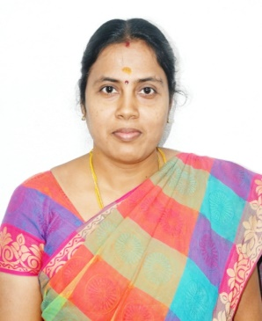**Date of Joining :** 02.01.2008

**Mrs.K.Sathyasundari, MCA**

**Associate Professor**

|  |  |
| --- | --- |
| **Field of Specialization** | Computer Science |
| **Phone No.** | 9789456750 |
| **E-Mail** | selvisathika@gmail.com |
| **Residential Address** | 9/11 B Subramaniam Street  Kalinga Rayanpalayaam  Bhavani,  Erode. |
| **Experience** | 15 Years |
| **Blood Group** | O+ Positive |

## Publication Details :

### International : 06

### National : 01

**Book Published :** 1

**Conference/ Workshop/ Symposium/ Seminar/FDP Attended :** 05