Name : Mr.K.Ramana Chandrachut

Qualification : M.Pharm

Department : Pharmacology

Designation : Associate Professor

Date of Joining : 04-06-2018

Area of Research : Neuropharmacology

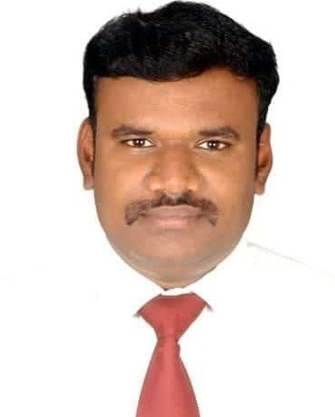

**Mr. Ramana Chandrachut**, **M.Pharm**

Associate Professor

|  |  |
| --- | --- |
| **Field of Specialization** | Pharmacology |
| **Phone No.** | 9789456750 |
| **E-Mail** | ramana200678jkkm@gmail.com |
| **Residential Address** | 250/2,Thoppukadu,  Alagapuram,  Salem District - 636 016 |
| **Experience** | 9 Years |
| **Blood Group** | B+ Positive |

Area of Research

➢  Drug discovery for Neurodegenerative disorders

* Drug discovery for CNS disorders

Publication Details :

National : 2

Project details :

UG : 2

Conference/ Workshop/ Symposium/ Seminar/FDP Attended : 6