**Name : Dr. Thalu Vahana**

**Qualification :** Pharm D

**Department :** Pharmacy Practice

**Designation :** Assistant Professor

**Date of Joining :** Jan 18,2023

**Area of Research :** Pharmacology, Therapeutics & Physiology

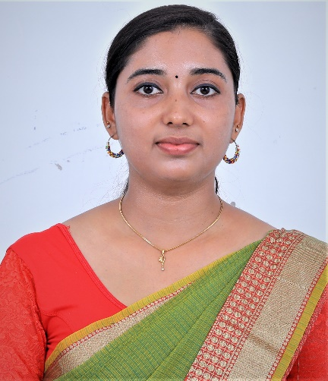

**Ms.Thalu Vahana**, **Pharm D**

**Assistant Professor**

|  |  |
| --- | --- |
| **Field of Specialization** | Clinical Pharmacist |
| **Phone No.** | 9789456750 |
| **E-Mail** | thaluvahana23@gmail.com |
| **Residential Address** | Chalil Puthan Purayil (H)  Pattavayal (PO)  TheNilgiris  Tamil Nadu |
| **Experience** | 3 yrs |
| **Blood Group** | O- Negative |

## Publication Details :

### International : 01

National : 01

**Conference/ Workshop/ Symposium/ Seminar/FDP Attended :** 02