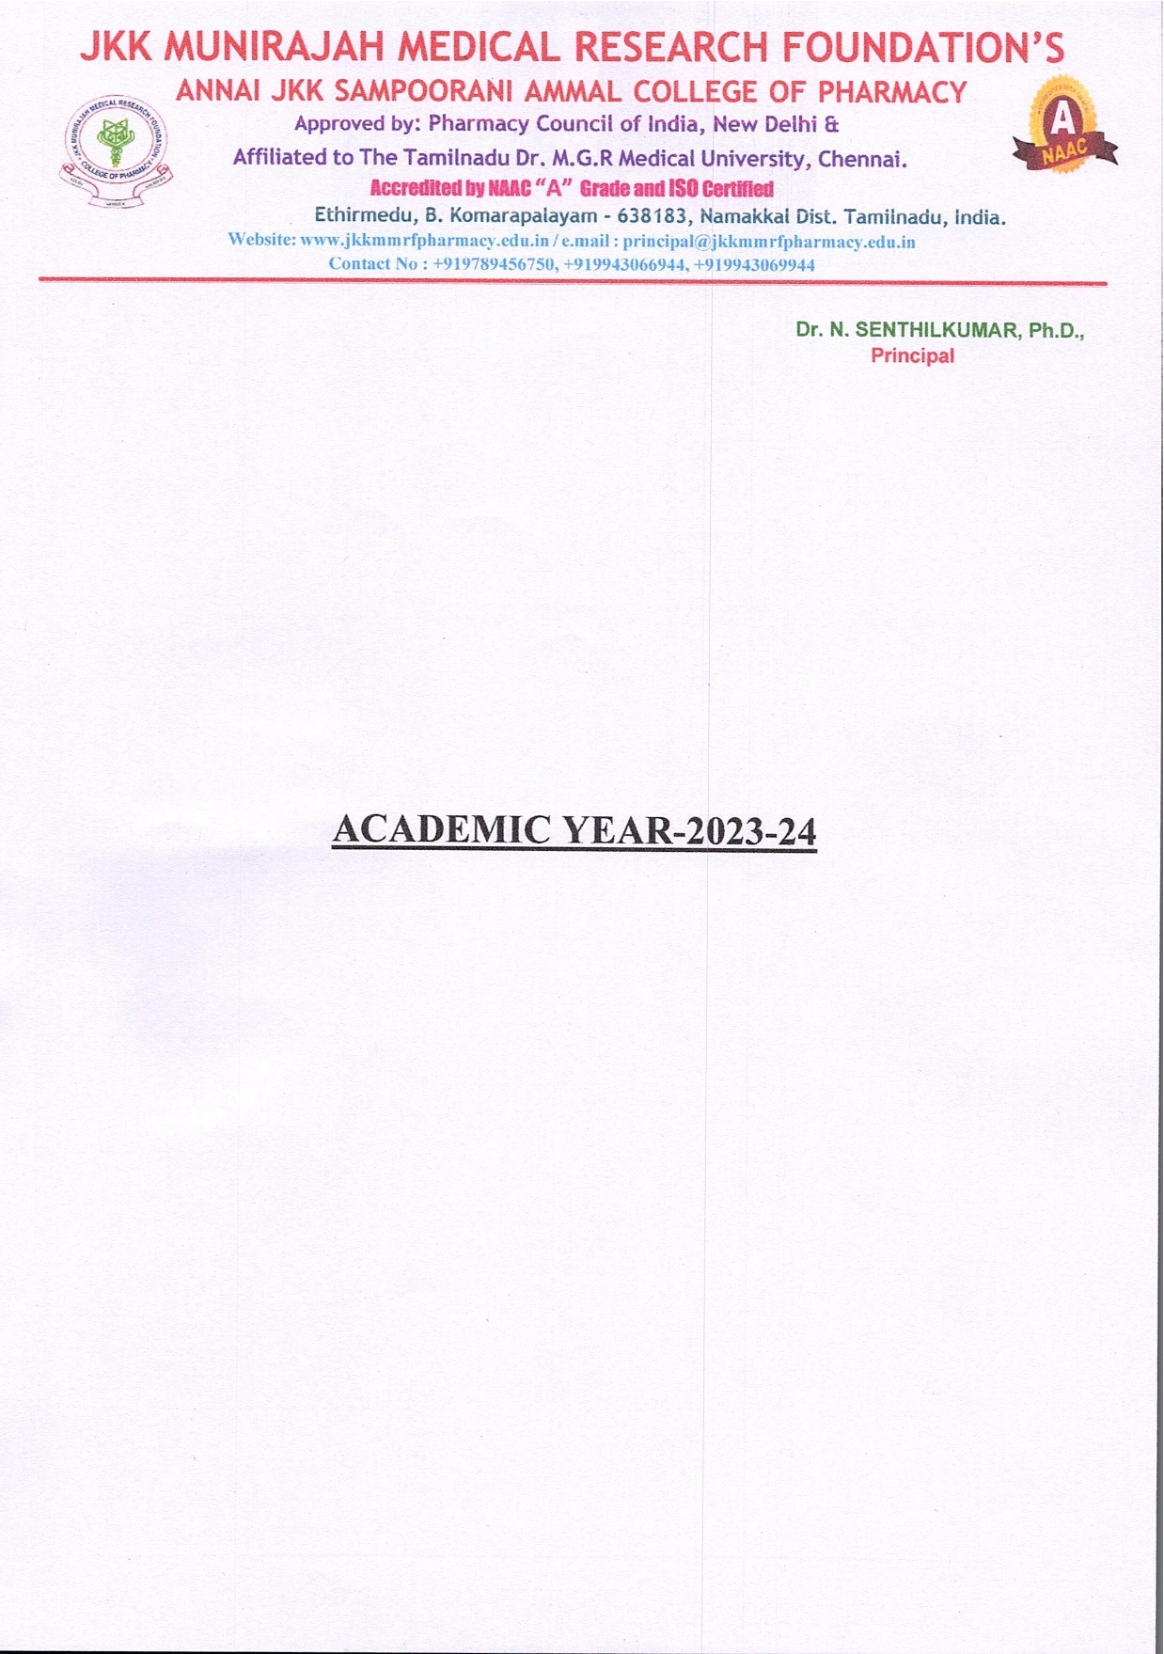

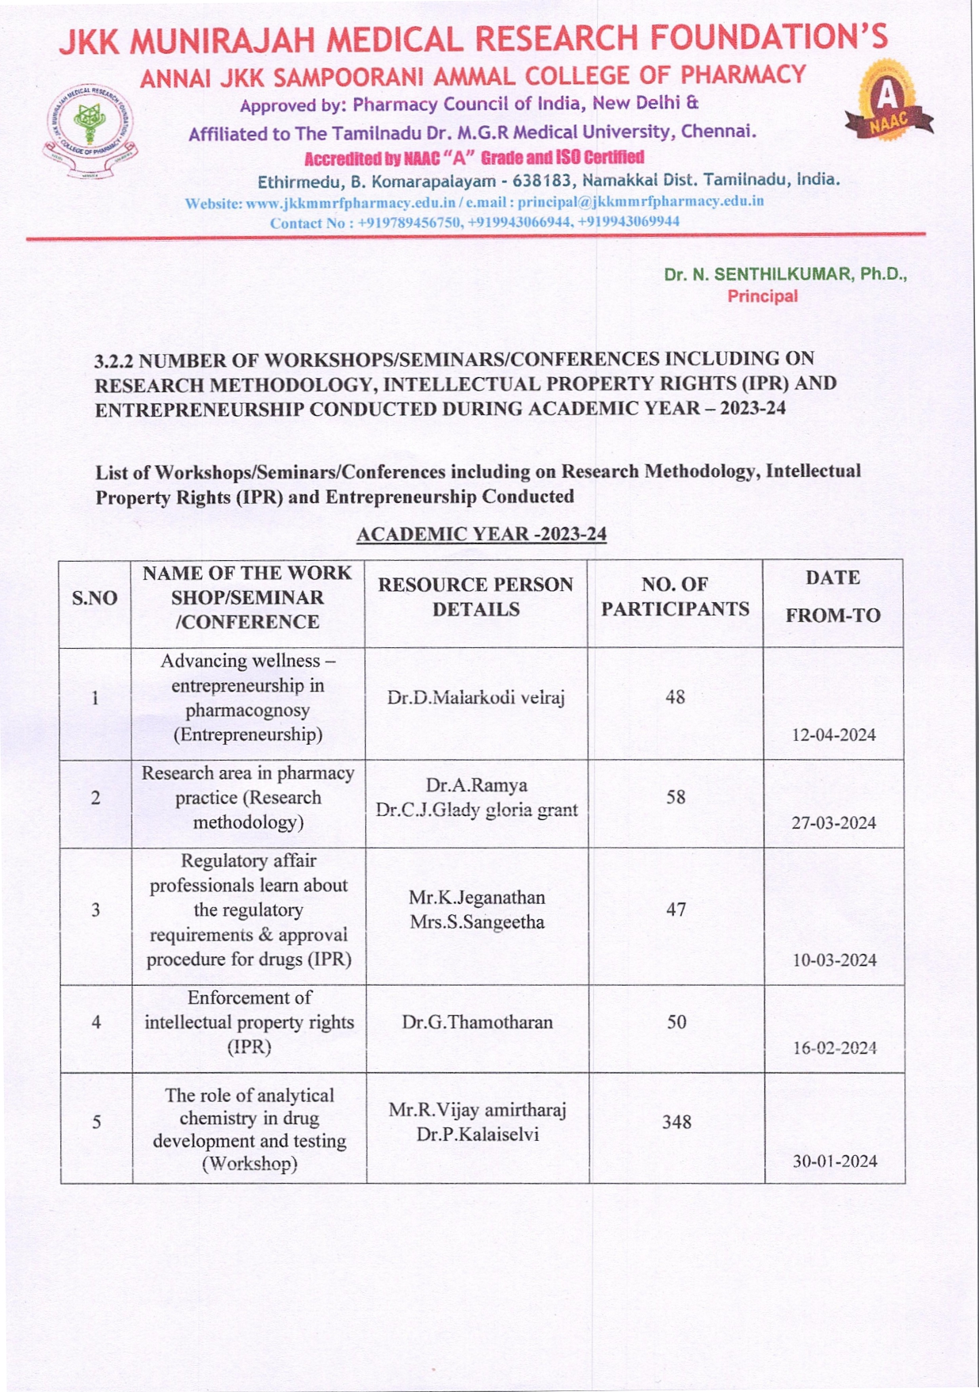

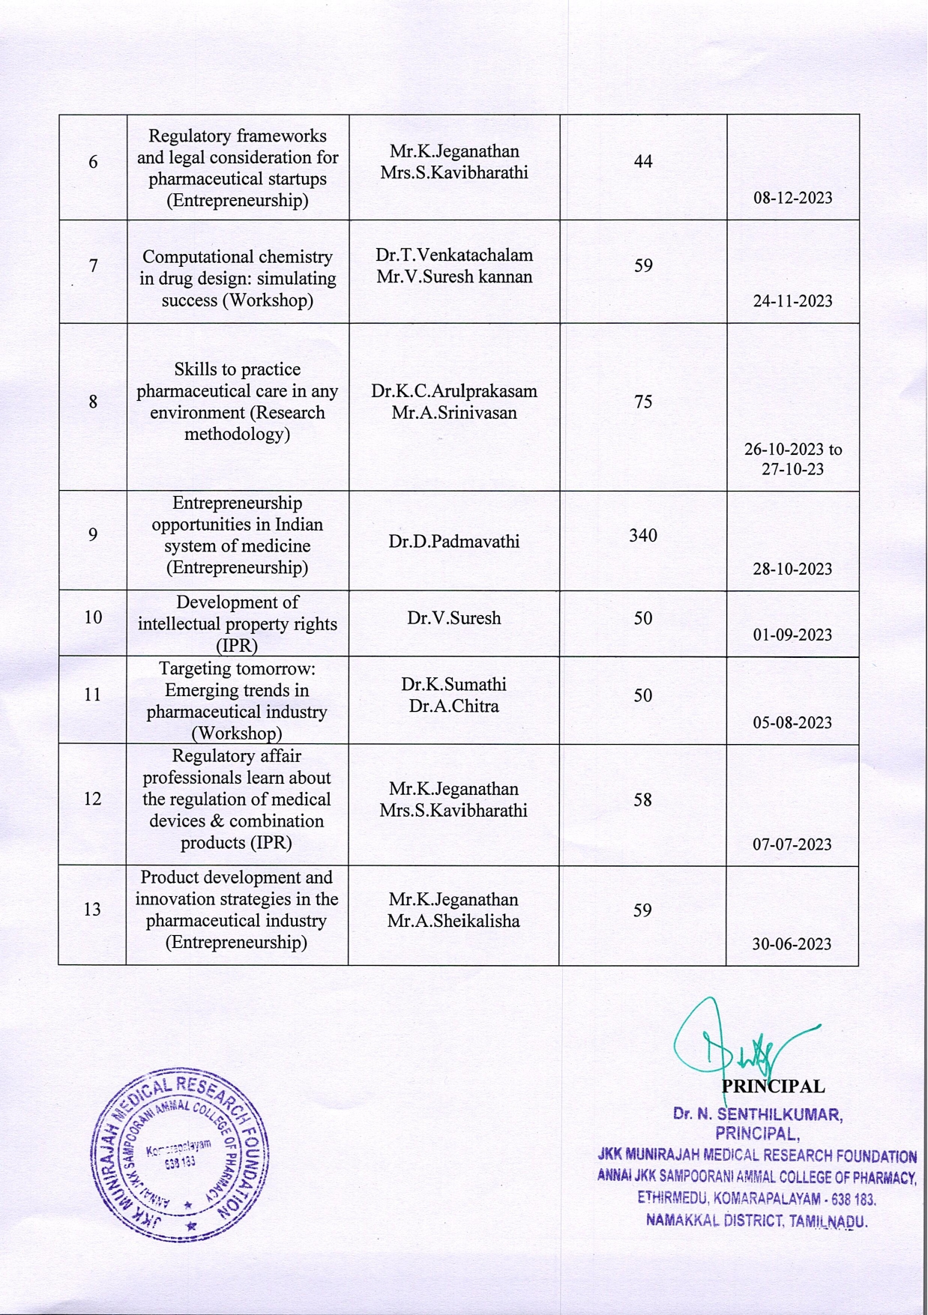

**List of Workshops/Seminars/Conferences including on Research Methodology, Intellectual Property Rights (IPR) and Entrepreneurship Conducted with Supporting Documents**

**ACADEMIC YEAR -2023-24**

|  |  |  |  |  |
| --- | --- | --- | --- | --- |
| **S.NO** | **NAME OF THE WORK SHOP/SEMINAR /CONFERENCE** | **NO. OF PARTICIPANTS** | **DATE**  **FROM-TO** | **LINK FOR SUPPORTING DOCUMENTS** |
| 1 | Advancing wellness – entrepreneurship in pharmacognosy (Entrepreneurship) | 48 | 12-04-2024 | View |
| 2 | Research area in pharmacy practice (Research methodology) | 58 | 27-03-2024 | View |
| 3 | Regulatory affair professionals learn about the regulatory requirements & approval procedure for drugs (IPR) | 47 | 10-03-2024 | View |
| 4 | Enforcement of intellectual property rights (IPR) | 50 | 16-02-2024 | View |
| 5 | The role of analytical chemistry in drug development and testing (Workshop) | 348 | 30-01-2024 | View |
| 6 | Regulatory frameworks and legal consideration for pharmaceutical startups (Entrepreneurship) | 44 | 08-12-2023 | View |
| 7 | Computational chemistry in drug design: simulating success (Workshop) | 59 | 24-11-2023 | View |
| 8 | Skills to practice pharmaceutical care in any environment (Research methodology) | 75 | 26-10-2023 to 27-10-23 | View |
| 9 | Entrepreneurship opportunities in Indian system of medicine (Entrepreneurship) | 340 | 28-10-2023 | View |
| 10 | Development of intellectual property rights (IPR) | 50 | 01-09-2023 | View |
| 11 | Targeting tomorrow: Emerging trends in pharmaceutical industry (Workshop) | 50 | 05-08-2023 | View |
| 12 | Regulatory affair professionals learn about the regulation of medical devices & combination products (IPR) | 58 | 07-07-2023 | View |
| 13 | Product development and innovation strategies in the pharmaceutical industry (Entrepreneurship) | 59 | 30-06-2023 | View |